

**Green University of Bangladesh**

**Department of Computer Science and Engineering (CSE)**

**Faculty of Sciences and Engineering**

**Semester: (Spring, Year:2022), B.Sc. in CSE (Day)**

**LAB REPORT NO #3**

**Course Title: Structured Programming Lab**

**Course Code: CSE 104 Section: D3**

**Lab Experiment Name: Decision making in C**

**Student Details**

| **Name** | | **ID** |
| --- | --- | --- |
| **1.** | **Md. Maruf Sarker** | **221002063** |

**Lab Date : 05-07-2022**

**Submission Date : 18-07-2022**

**Course Teacher’s Name : Ahmed Iqbal Pritom**

**[For Teachers use only: Don’t Write Anything inside this box]**

| **Lab Report Status**  **Marks: ………………………………… Signature:.....................**  **Comments:.............................................. Date:..............................** |
| --- |

**1. TITLE OF THE LAB EXPERIMENT**

Decision making in C

**2. OBJECTIVES/AIM [1]**

1. Take two numbers from the user. Find the largest number.
2. Take a number from the user. Print if the number is

positive/negative/zero.

1. Take 3 numbers from the user. Find the minimum number.
2. Take a person’s salary from the user. Give him a 25% increment if his salary is less than 10000. Give a 10% increment if his salary is greater than 50000. Otherwise, just provide him a 5000 taka increment. Print his updated salary.
3. Collect a person’s age and gender. Print if he/she is eligible for voting or not.
4. Collect a person’s age and gender. Print if he/she is eligible for marriage or not.
5. Take an integer number from the user. Print if the number is even-positive/ odd-positive / even-negative / odd-negative?
6. Take a student’s math marks as input. Calculate his grade.
7. Write a C program to design a simple CALCULATOR.
8. Check if a given year is a leap year or not.
9. Take 3 sides of a triangle. Check if the triangle is valid or not.
10. Take 3 angles of a triangle. Check if the triangle is valid or not.
11. Write a C Program to Check Whether a Character is a Vowel or Consonant.
12. Write a C program to accept a coordinate point in a XY coordinate system and determine in which quadrant the coordinate point lies.
13. Write a C program to check whether a triangle is Equilateral, Isosceles, or Scalene.
14. Write a program in C to calculate and print the Electricity bill of a given customer. The unit consumed by the user should be taken from the keyboard and display the total amount to pay to the customer. The charge is as follows:

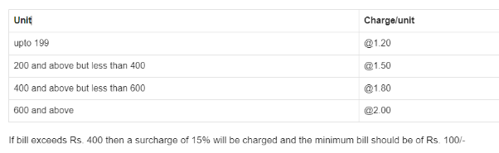

1. Take a character from the keyboard. Check if the character is a vowel/consonant/digit/special symbol.

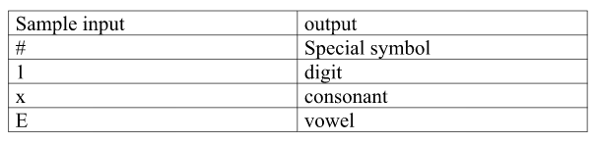

**3. PROCEDURE / ANALYSIS / DESIGN [2]**

**Task-1:**

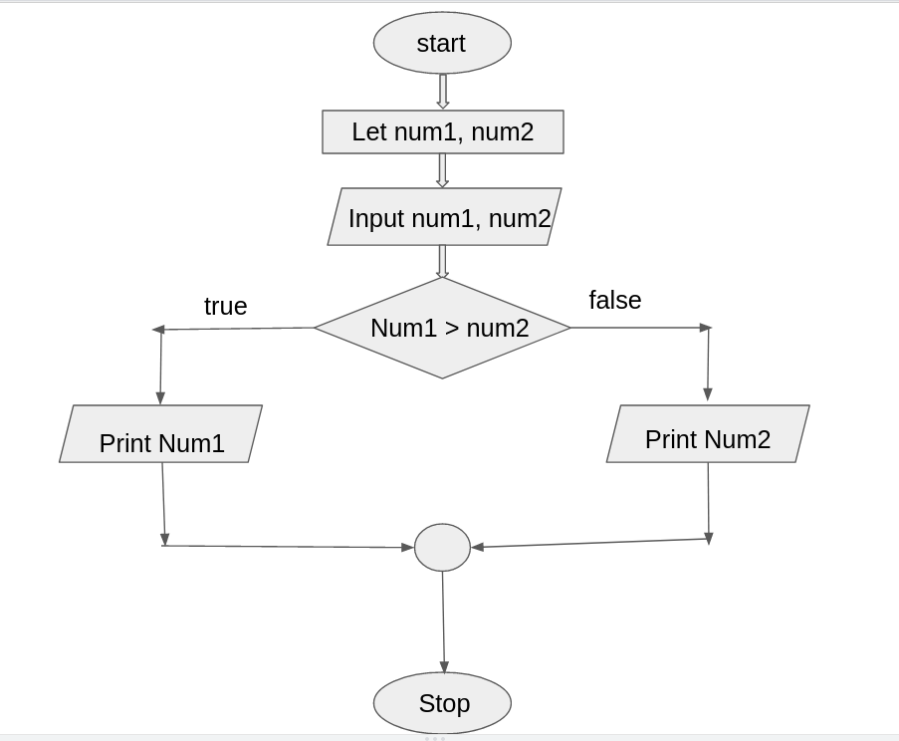

**Task-2:**

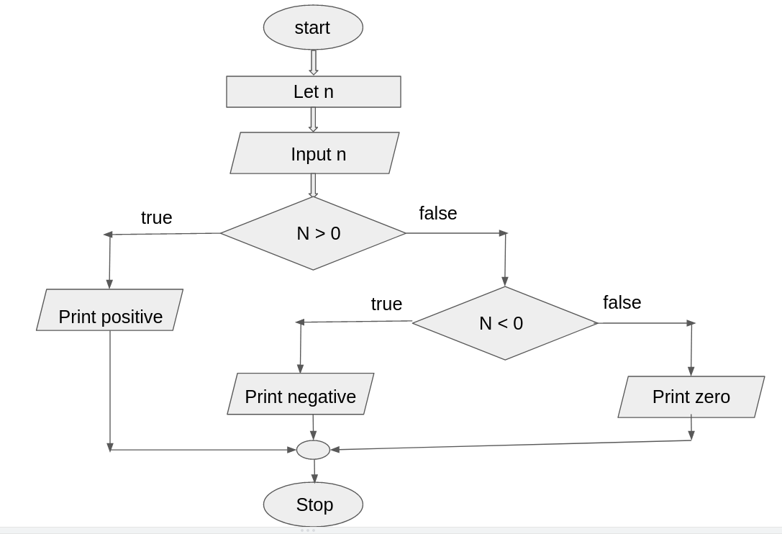

**Task-3:**

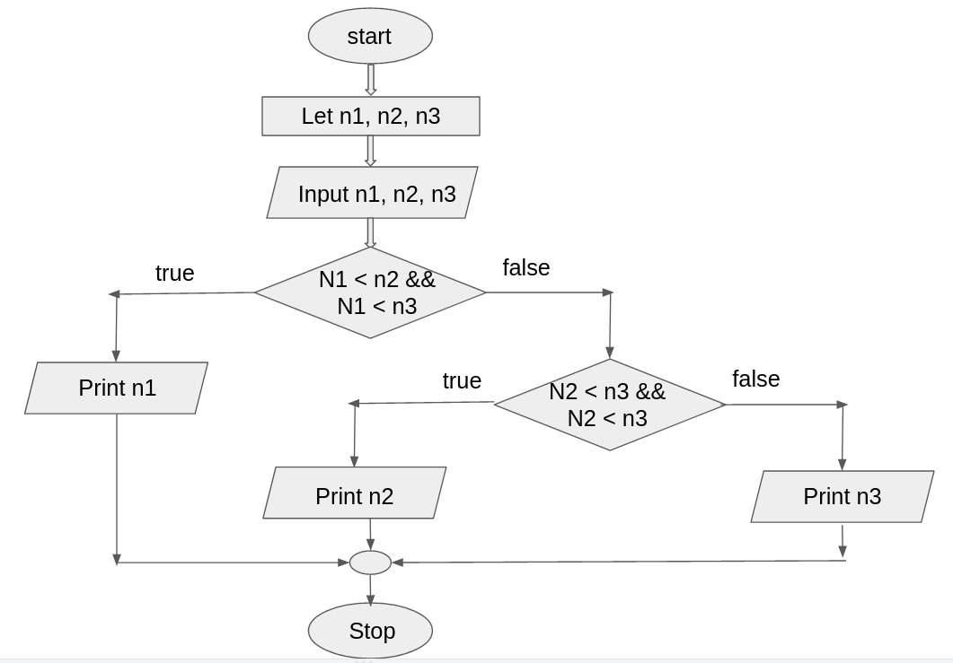

**Task-4:**

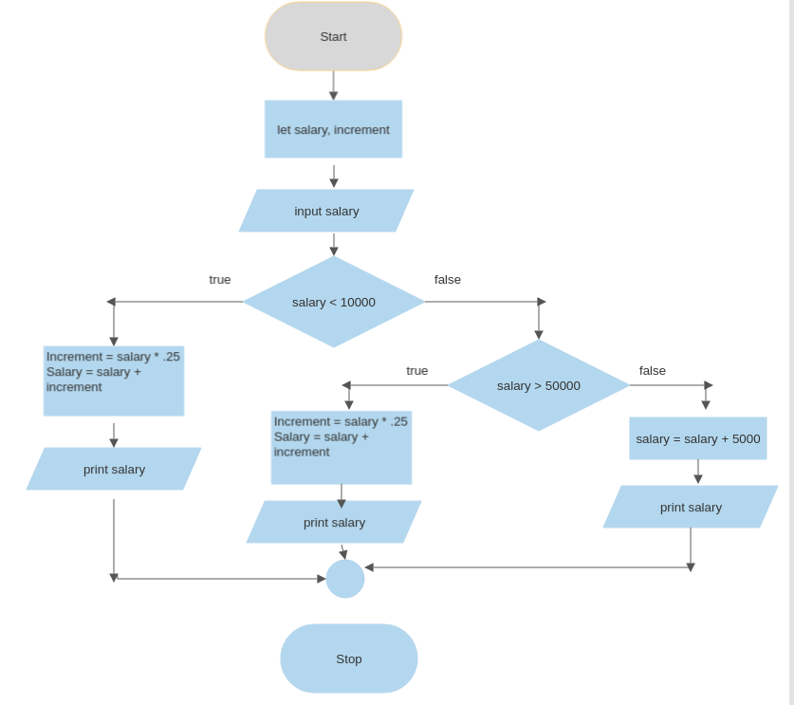

**Task-5:**

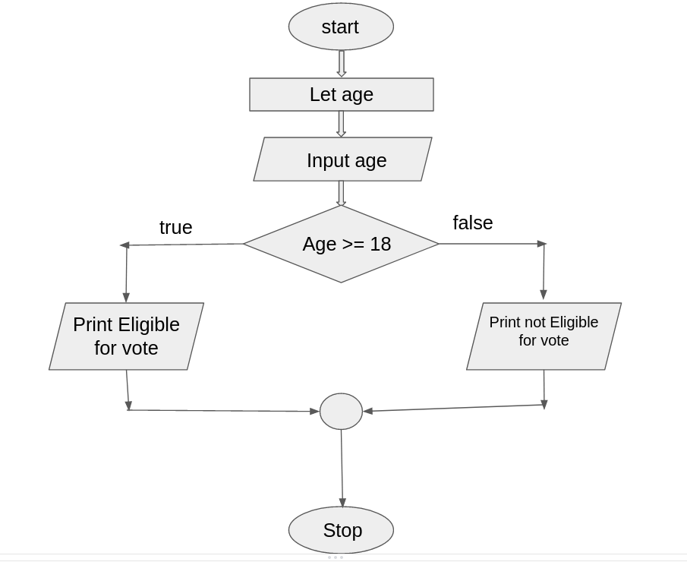

**Task-6:**

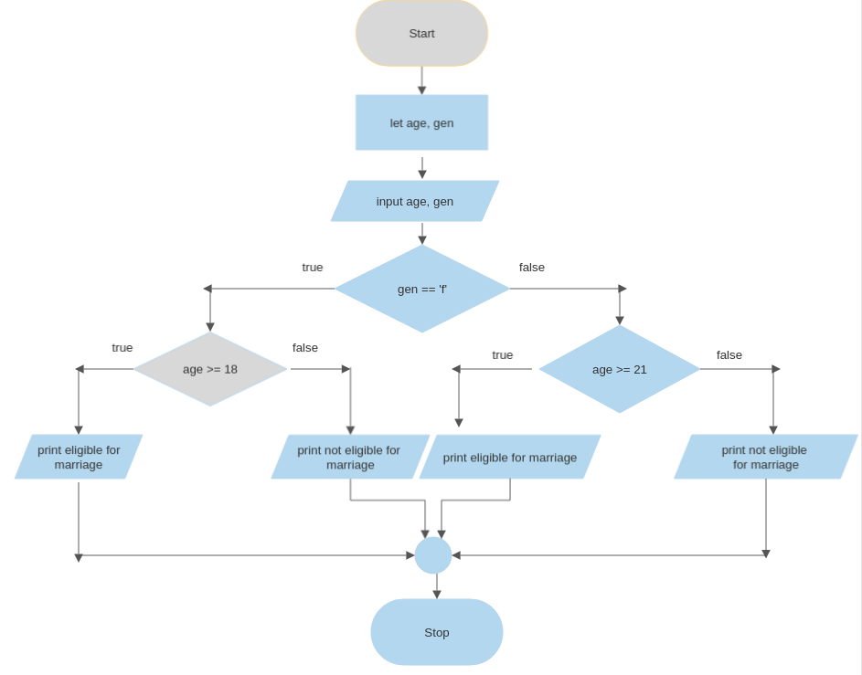

**Task-7:**

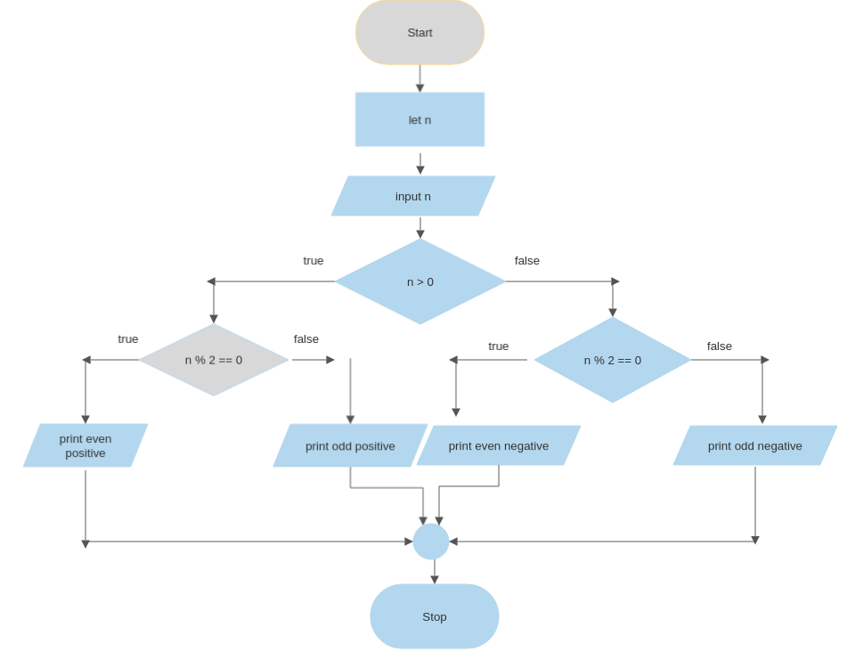

**Task-8:**

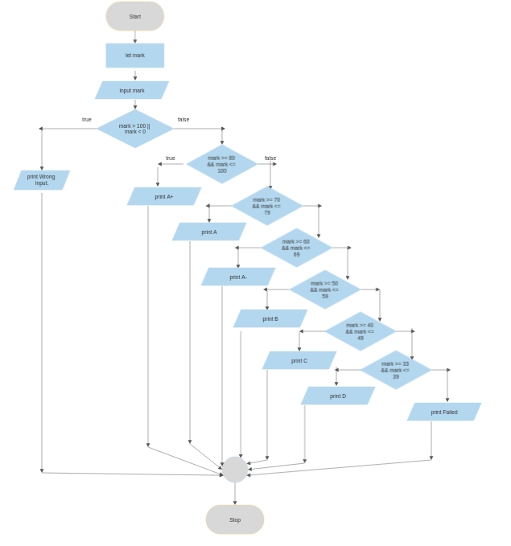

**Task-9:**

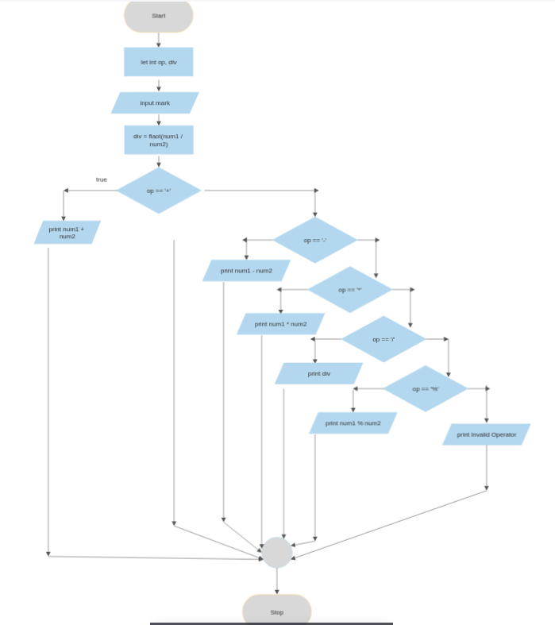

**Task-10:**

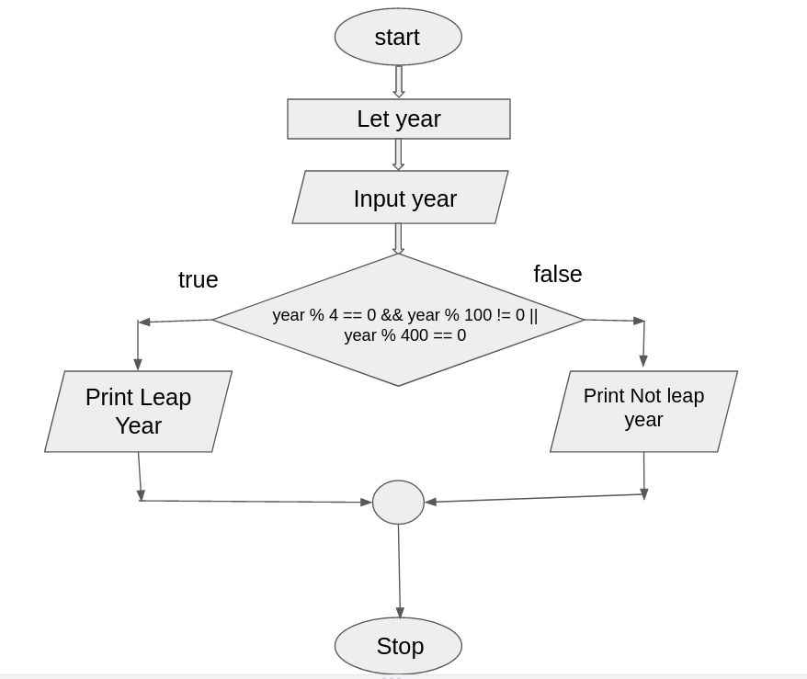

**Task-11:**

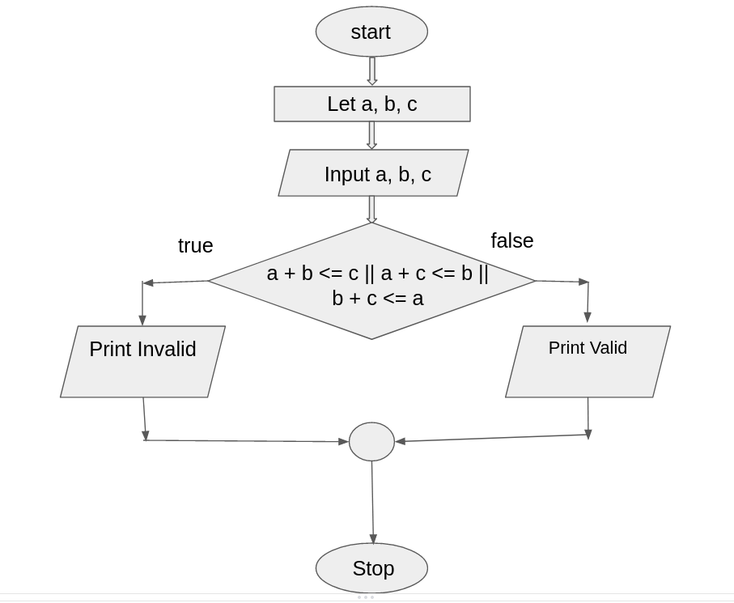

**Task-12:**

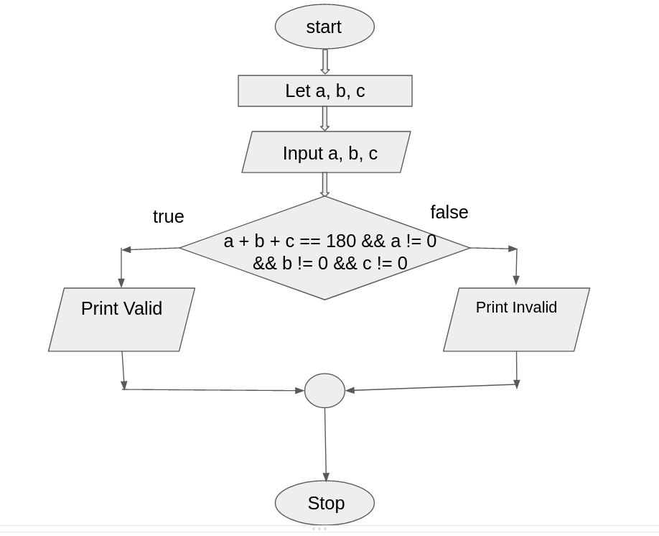

**Task-13:**

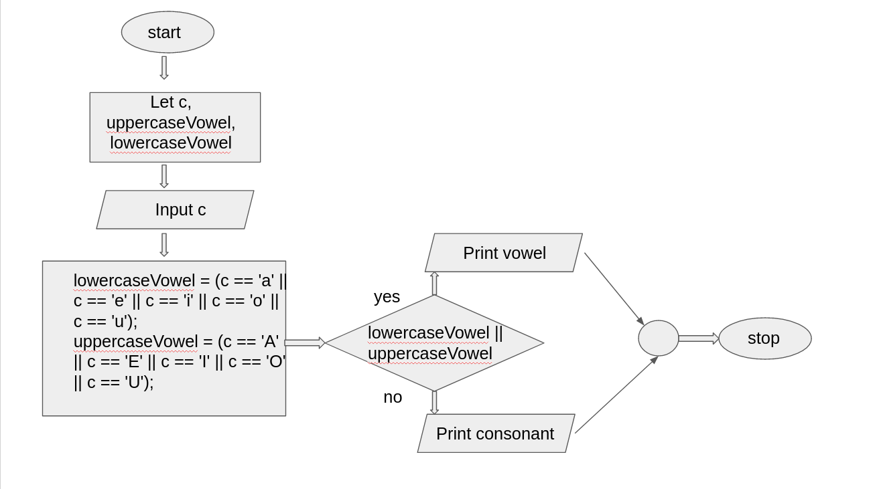

**Task-14:**

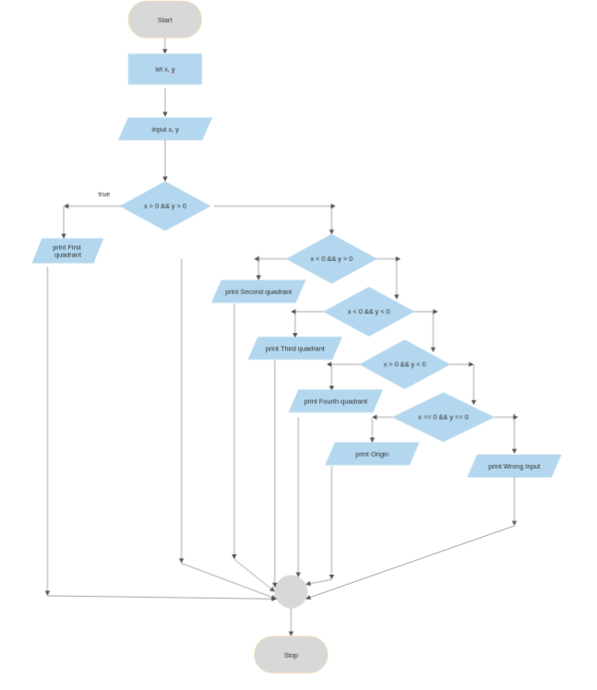

**Task-15:**

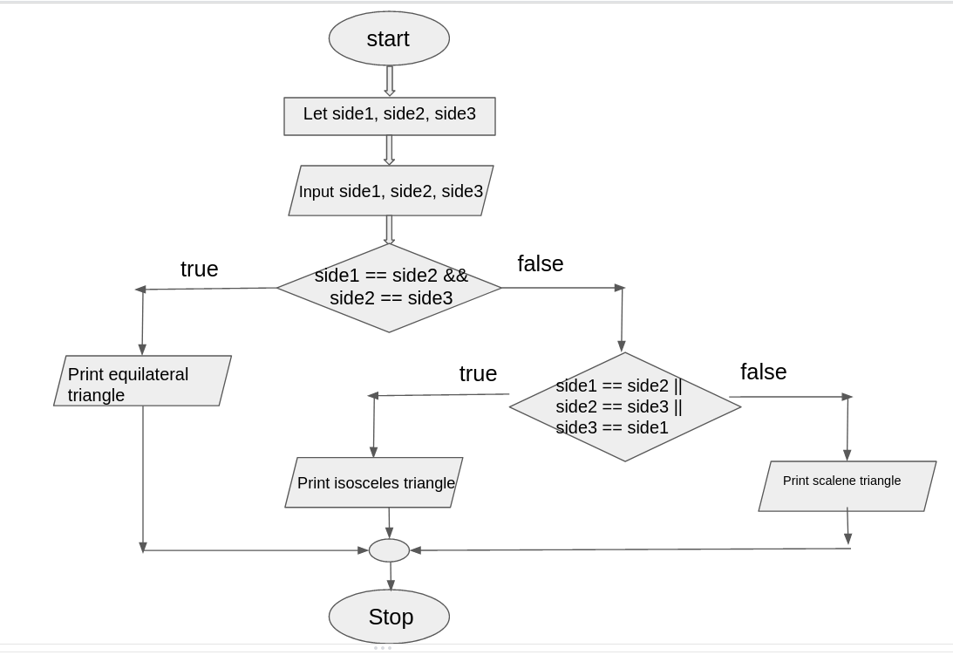

**Task-16:**

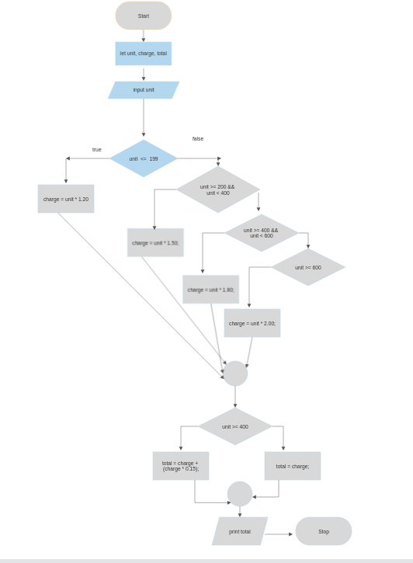

**Task-17:**

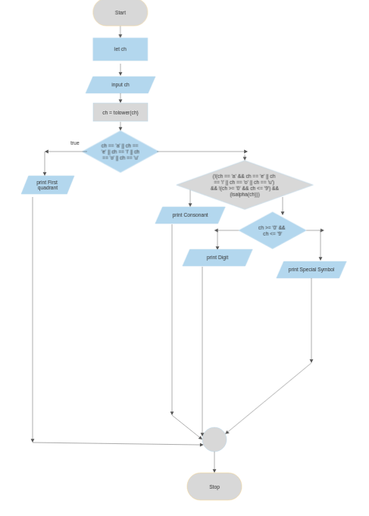

**4. IMPLEMENTATION [2]**

**Using If…Else Conditional Statement**

**Task-1:**

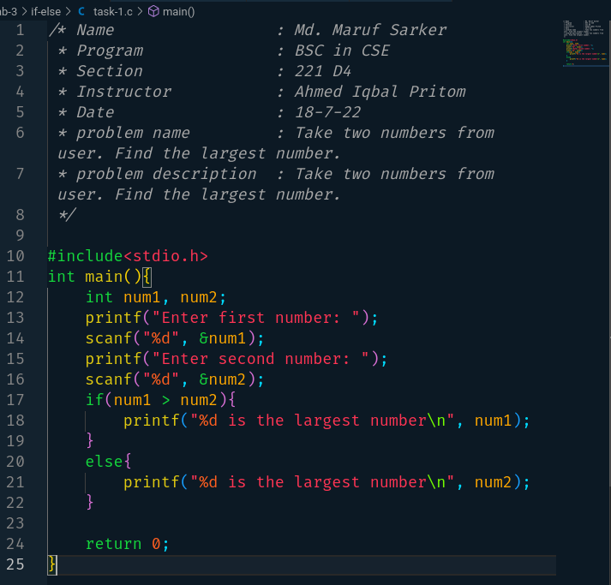

**Task-2:**

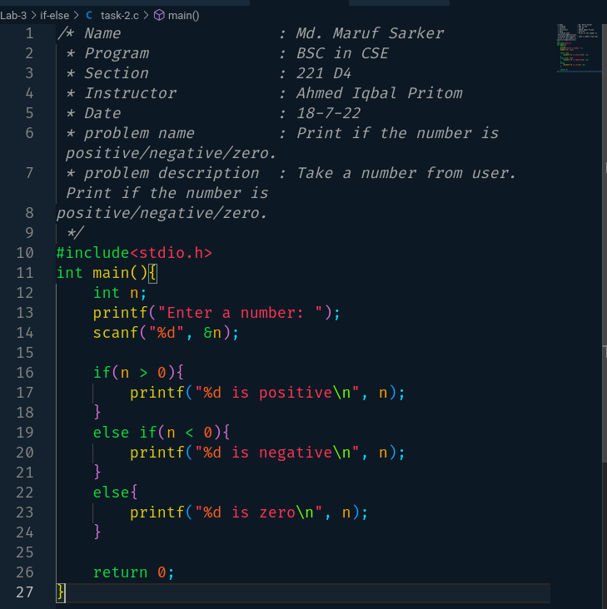

**Task-3:**

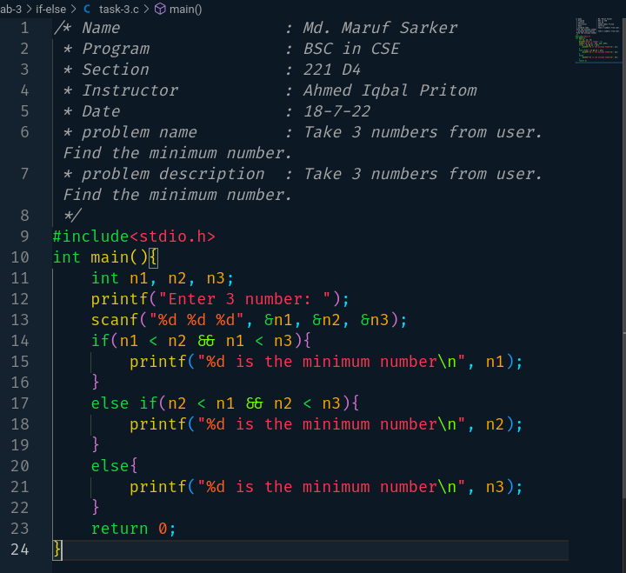

**Task-4:**

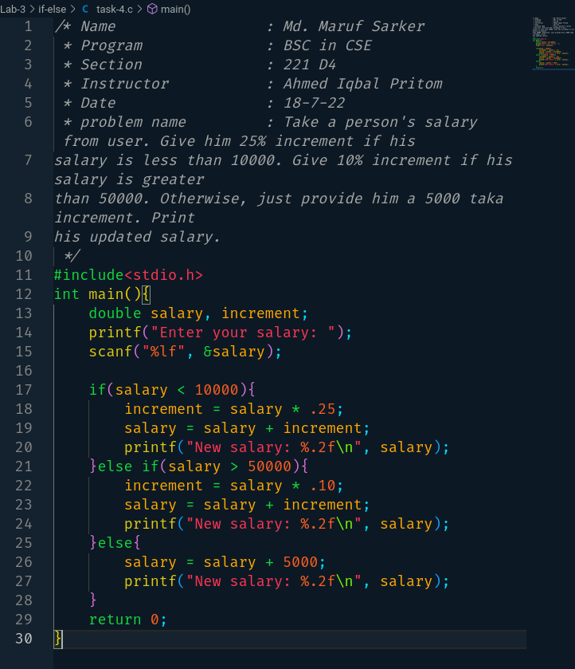

**Task-5:**

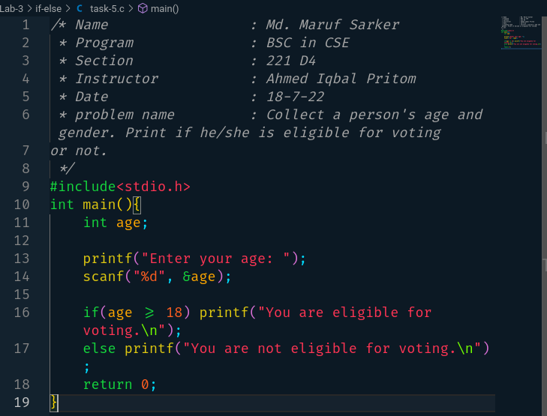

**Task-6:**

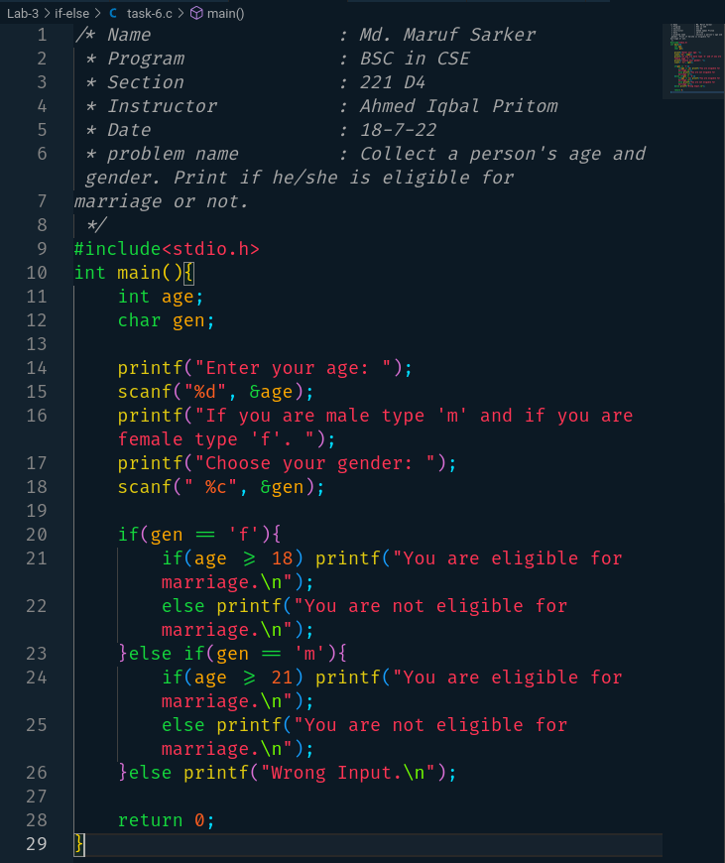

**Task-7:**

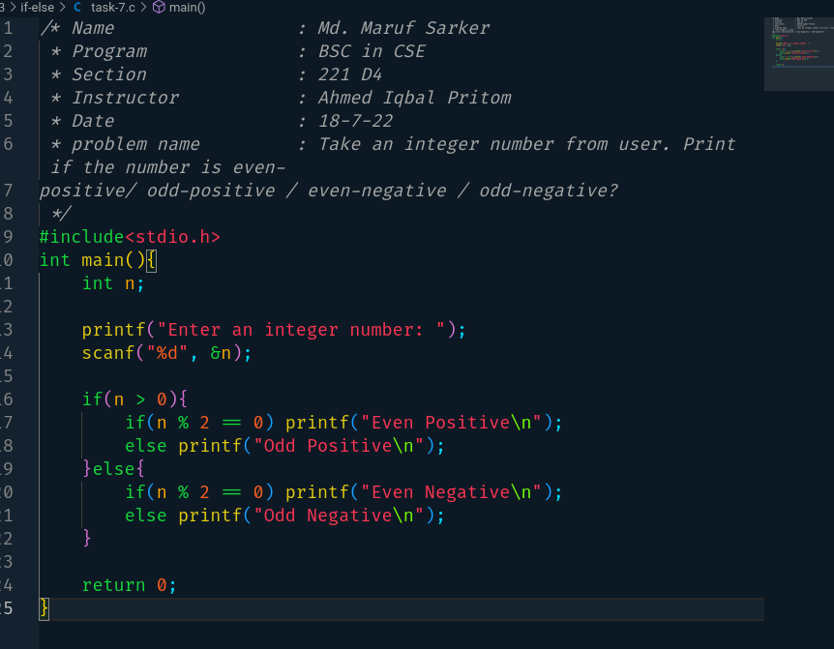

**Task-8:**

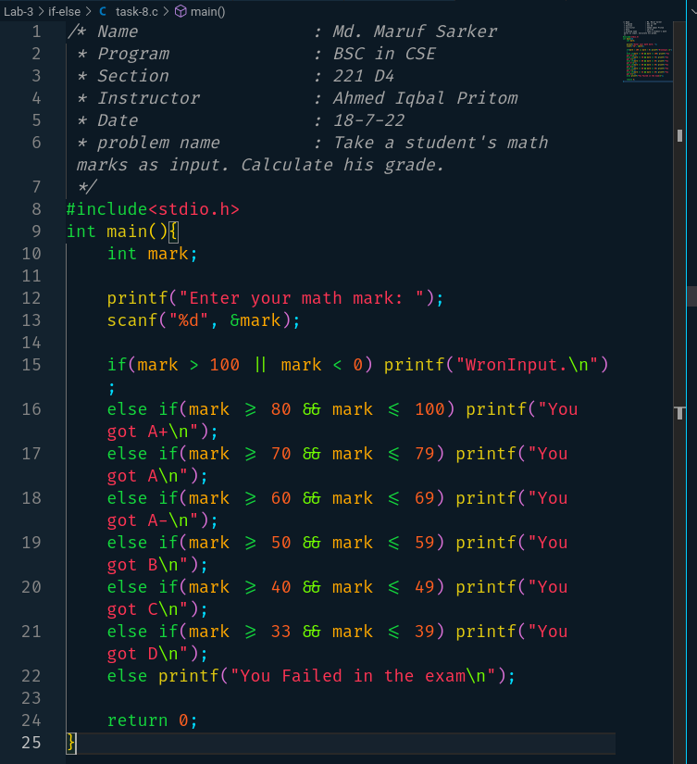

**Task-9:**

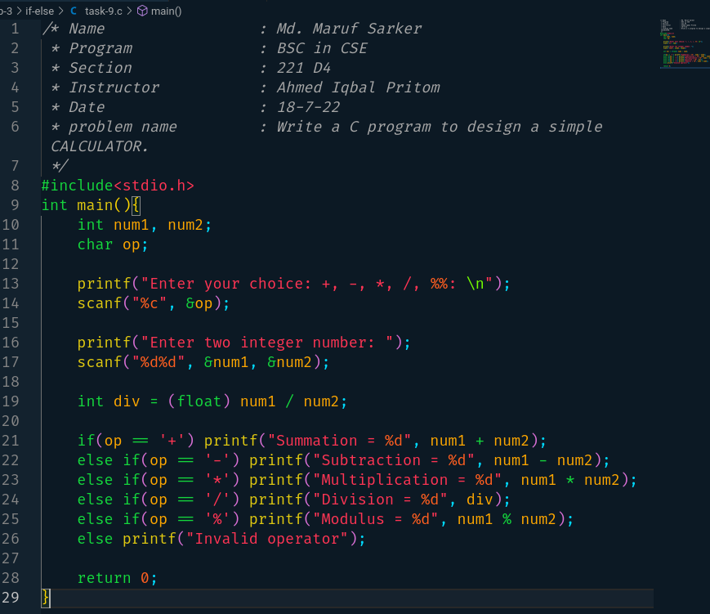

**Task10:**

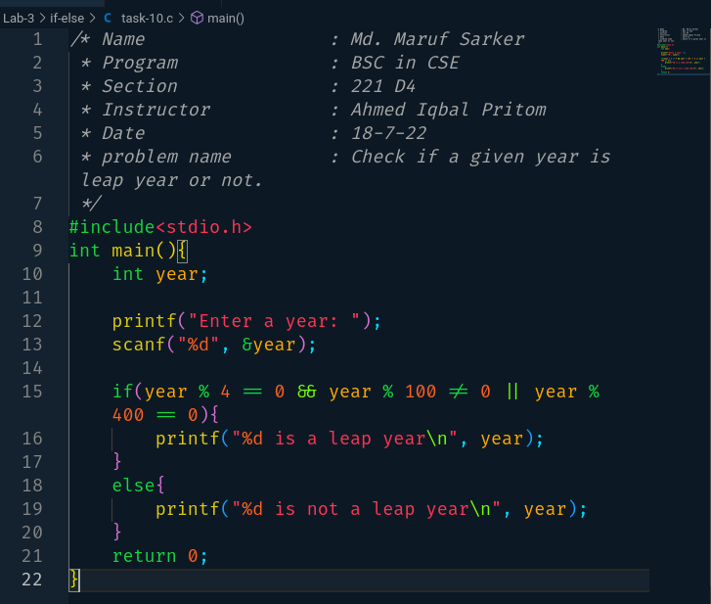

**Task-11:**

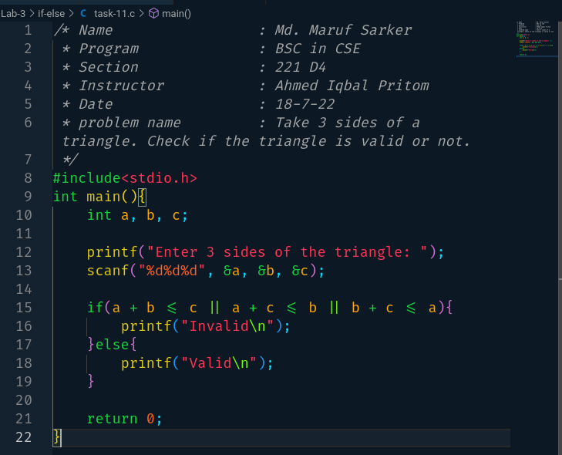

**Task-12:**

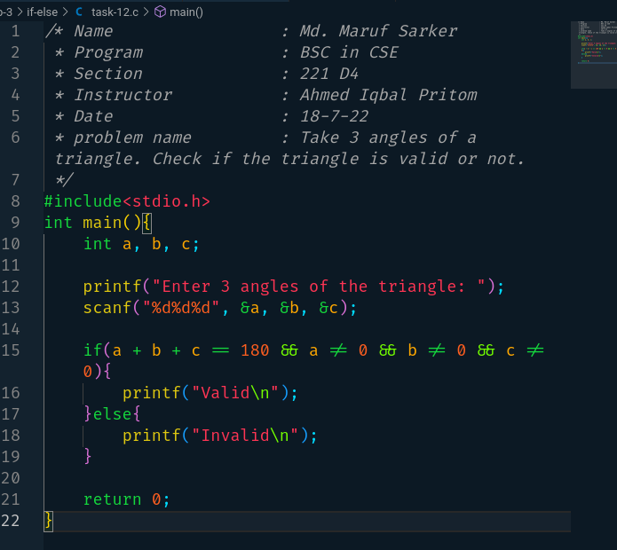

**Task-13:**

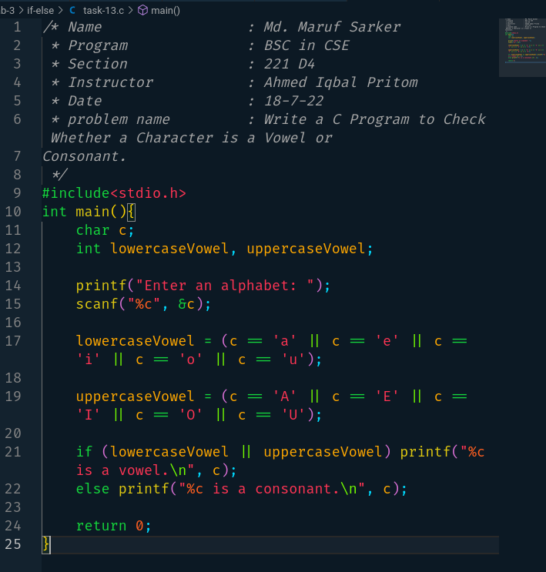

**Task-14:**

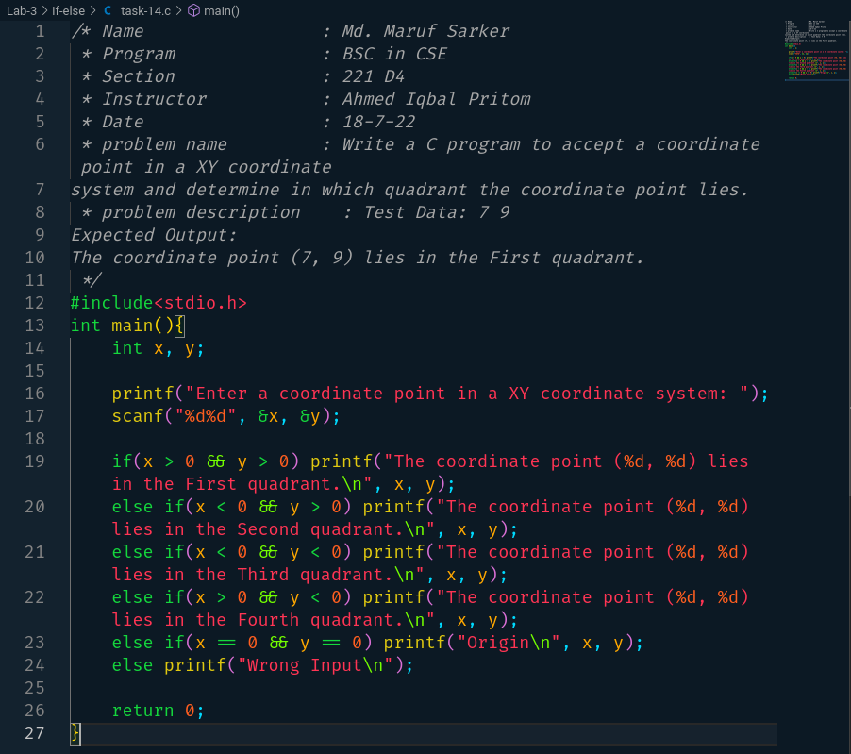

**Task-15:**

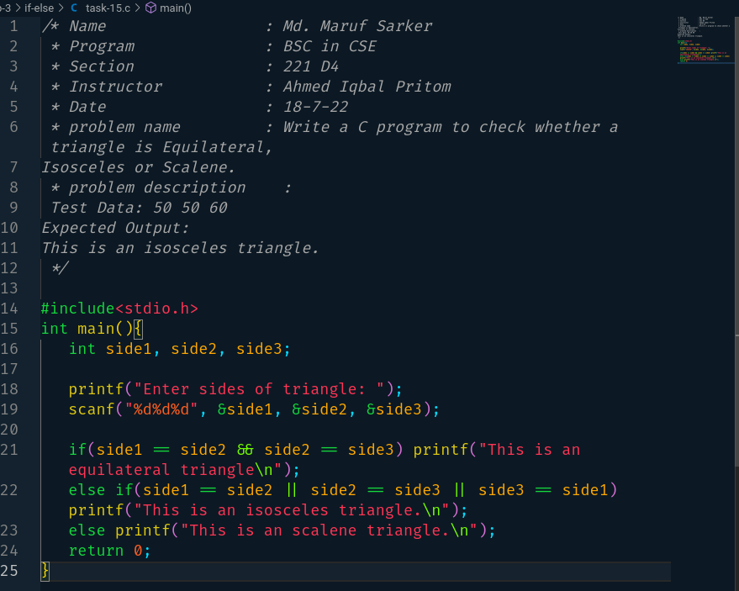

**Task-16:**

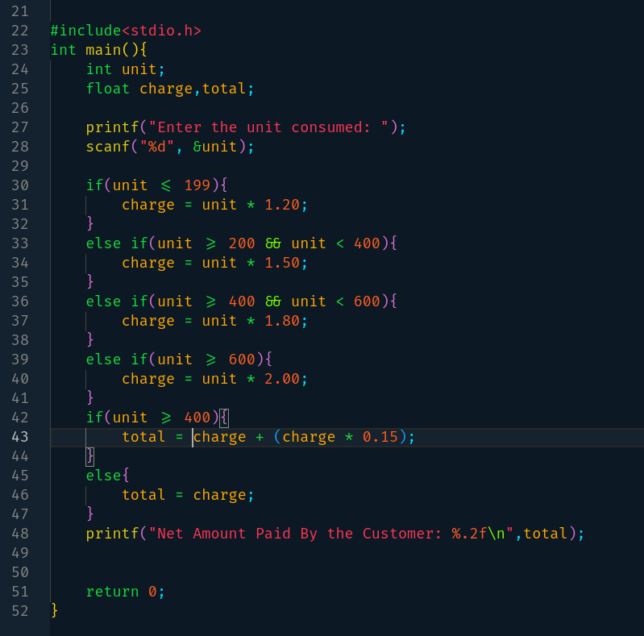

**Task-17:**

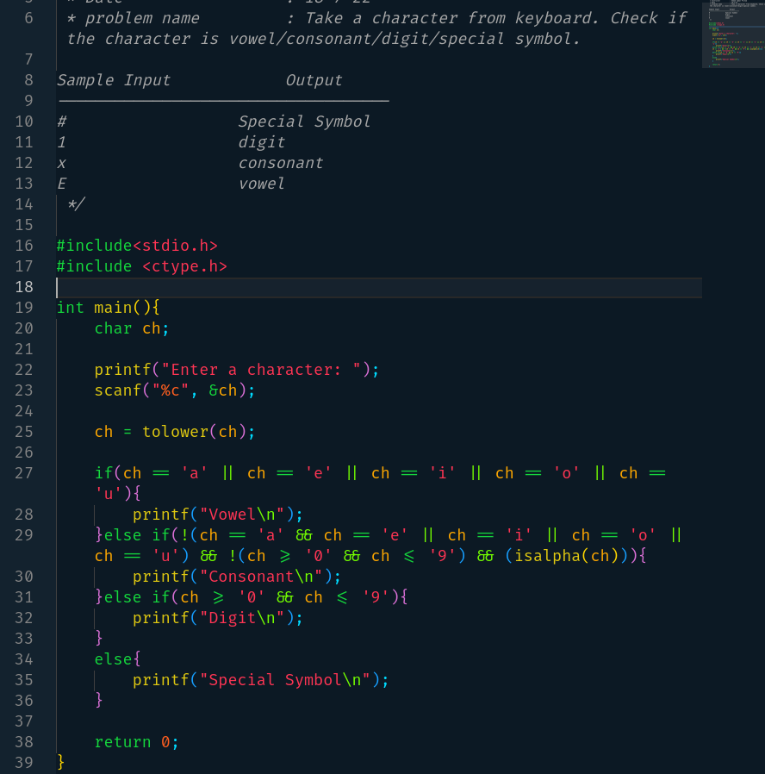

**Using Switch Statement**

**Task-1:**

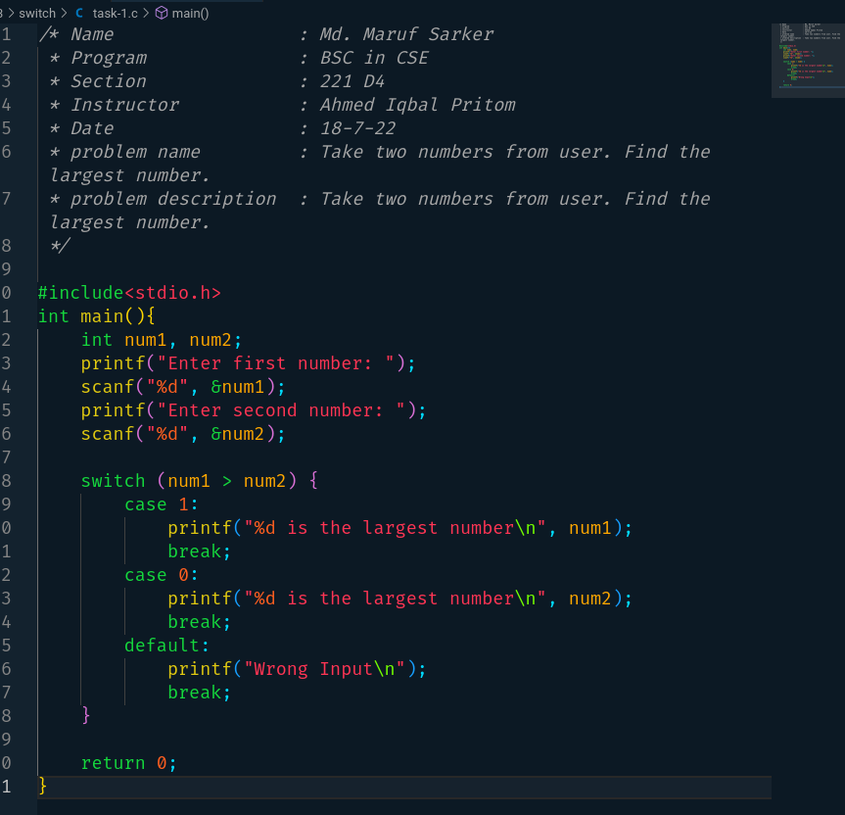

**Task-2:**

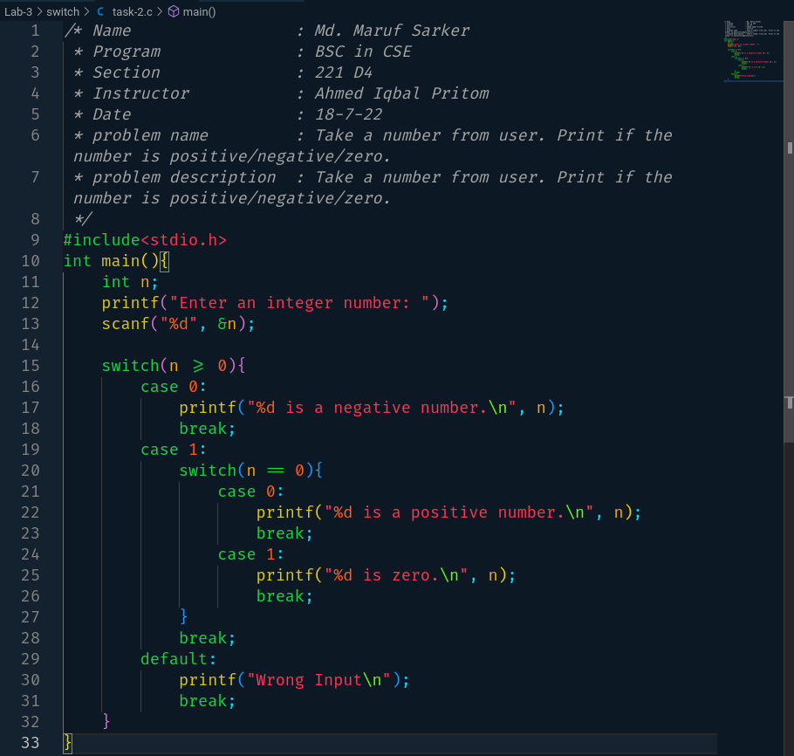

**Task-3:**

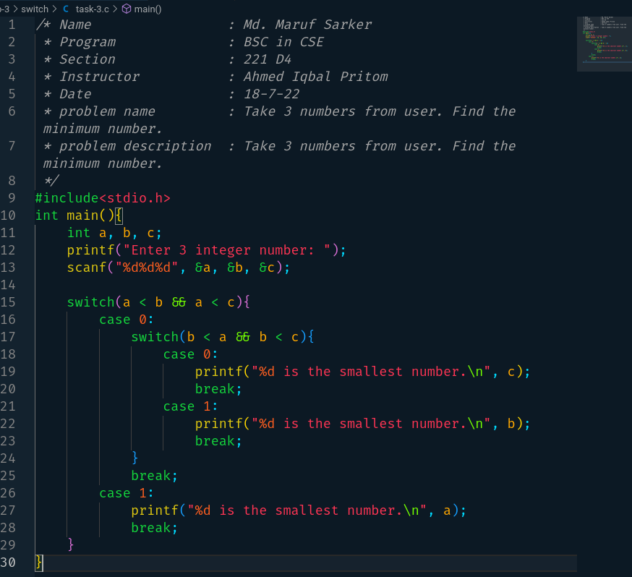

**Task-4:**

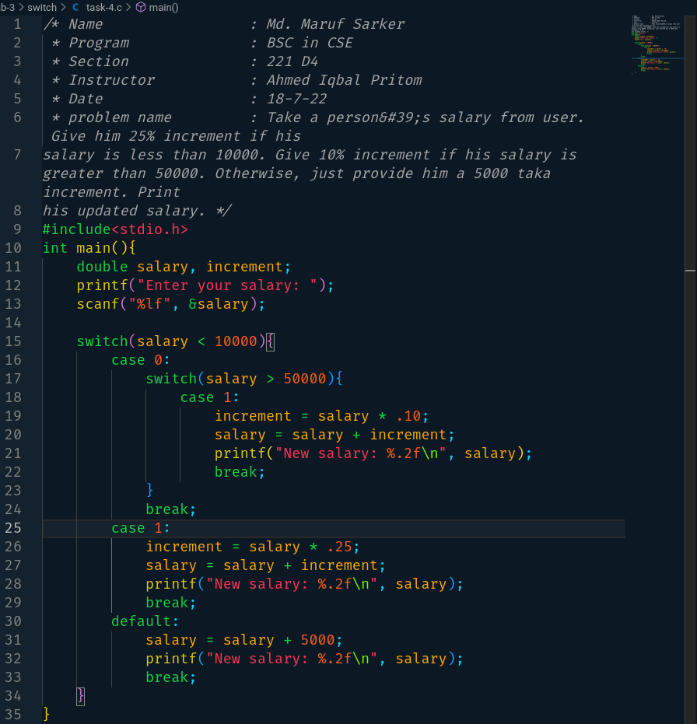

**Task-5:**

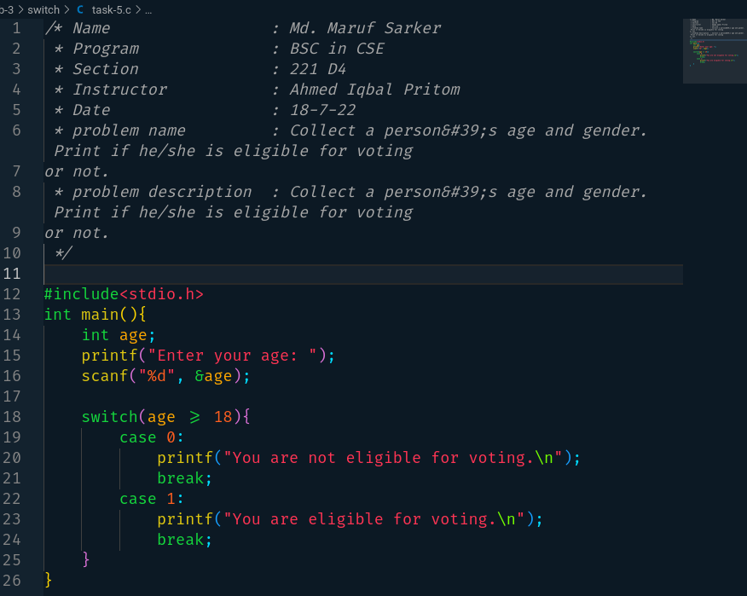

**Task-6:**

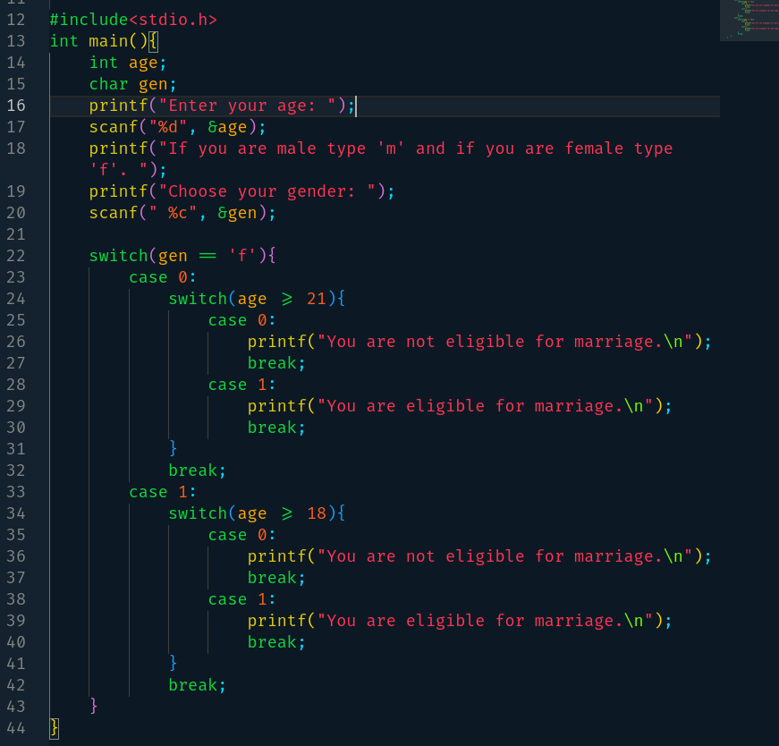

**Task-7:**

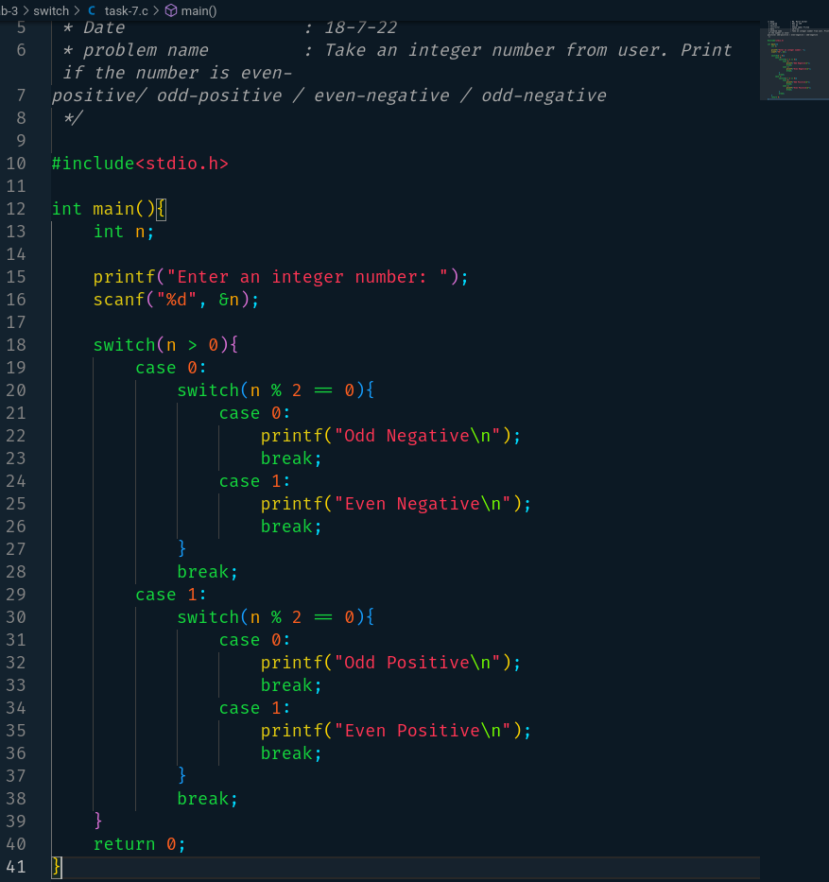

**Task-8:**

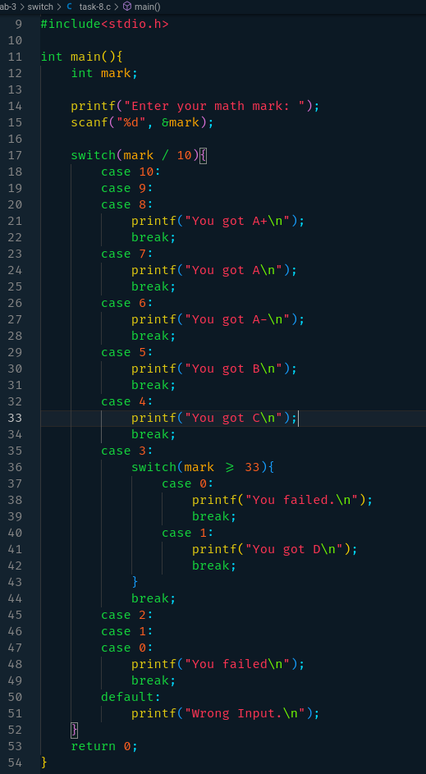

**Task-9:**

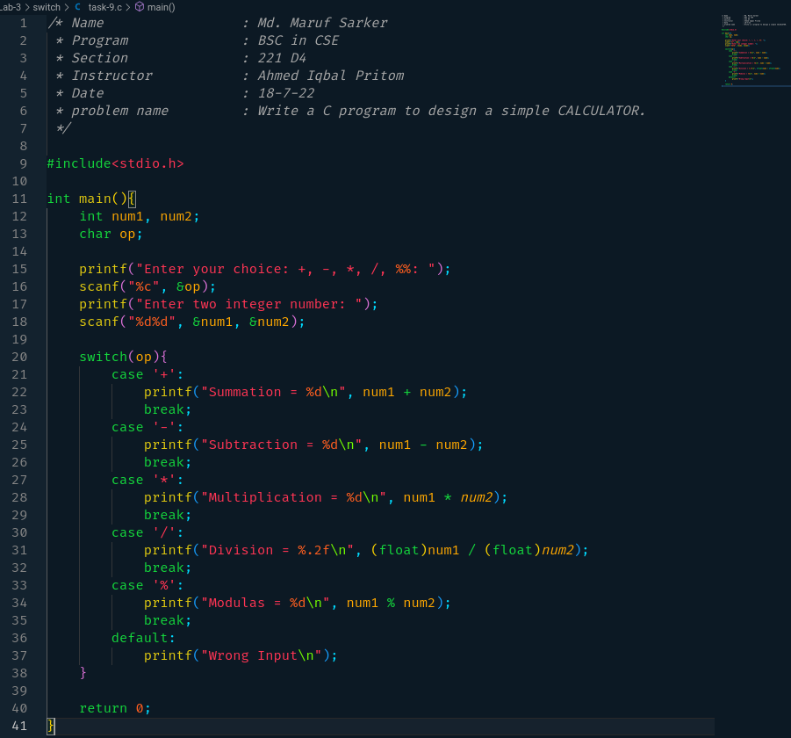

**Task-10:**

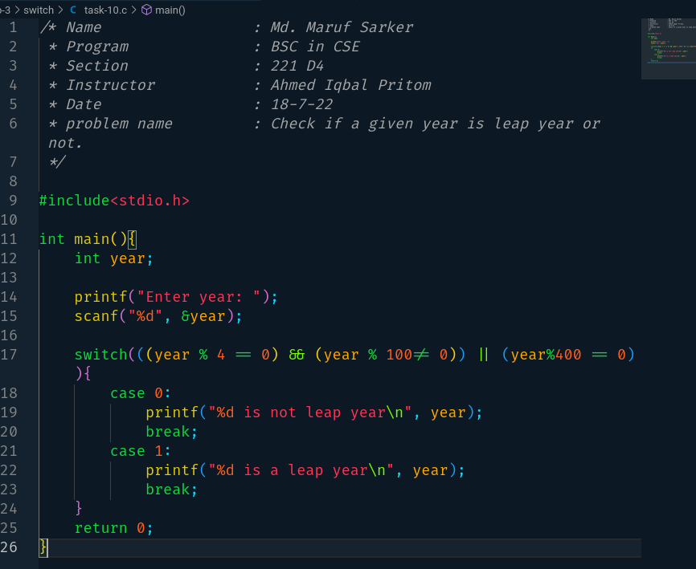

**Task-11:**

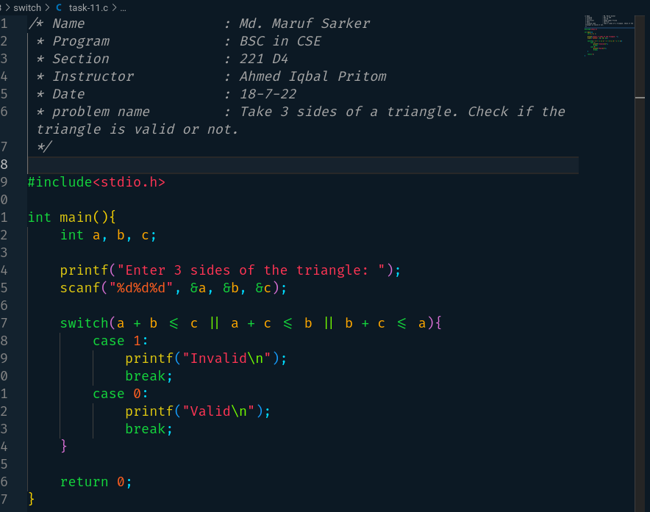

**Task-12:**

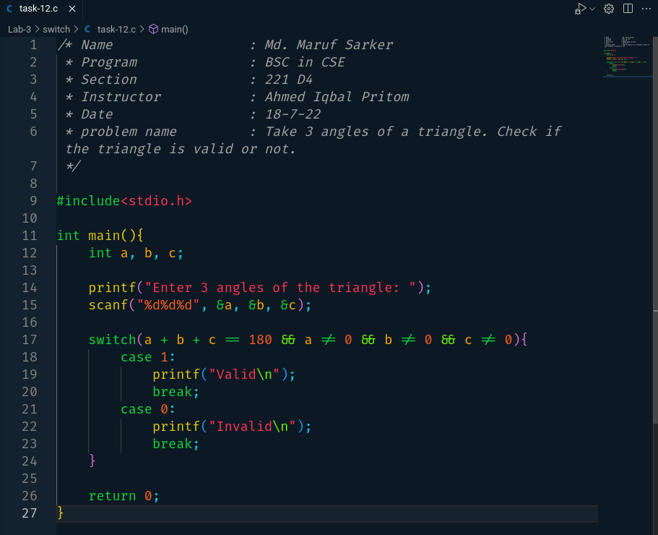

**Task-13:**

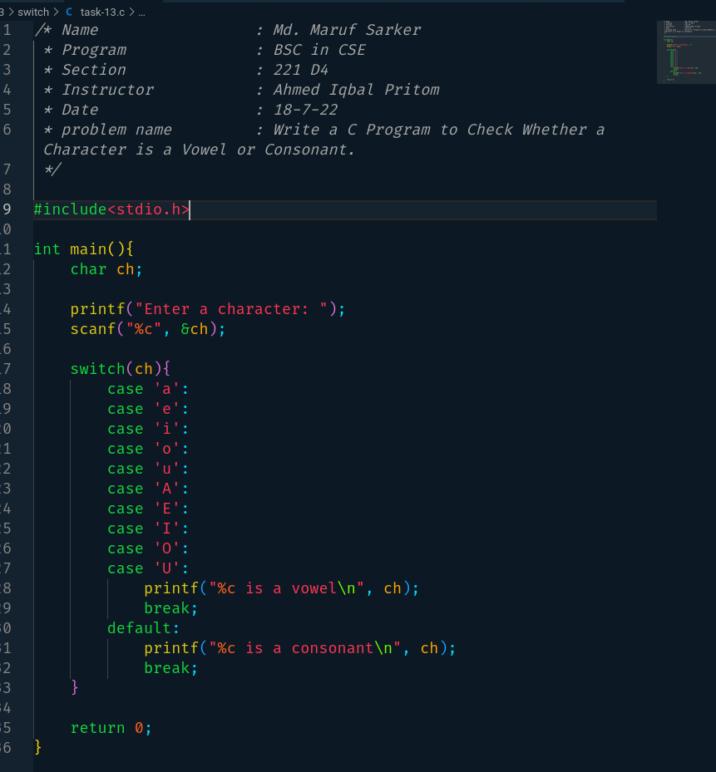

**Task-14:**

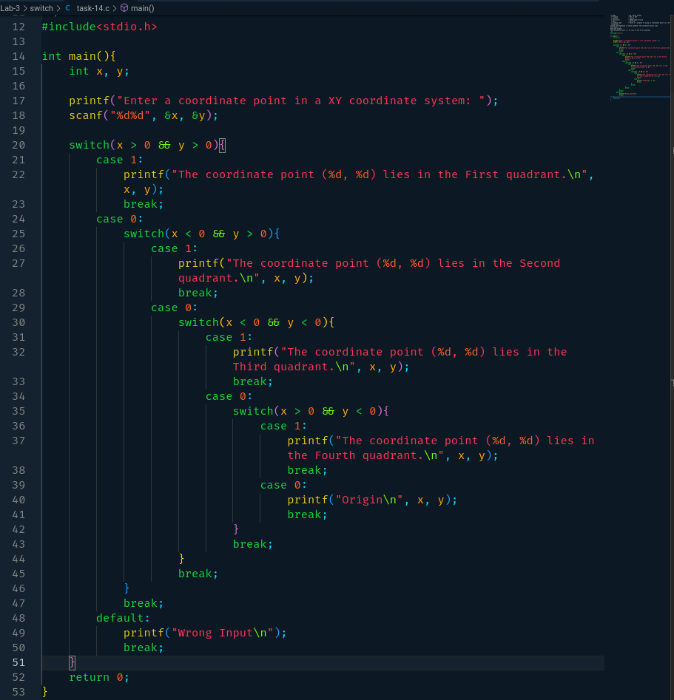

**Task-15:**

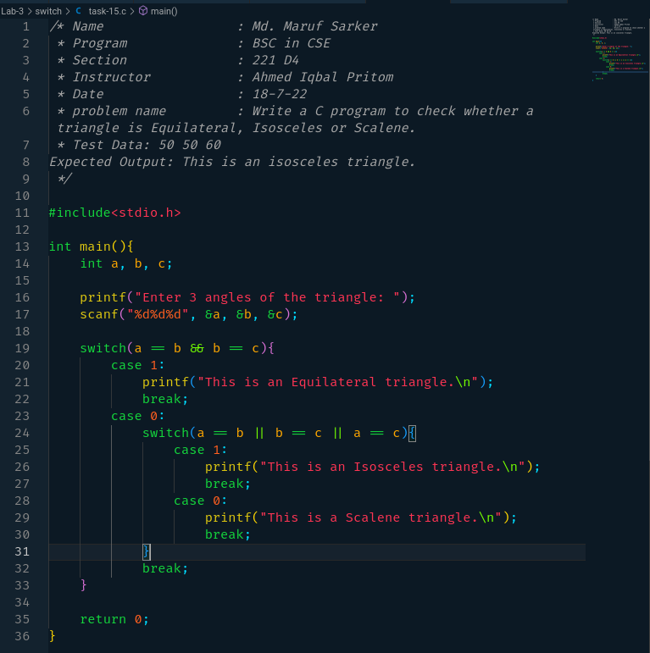

**Task-16:**

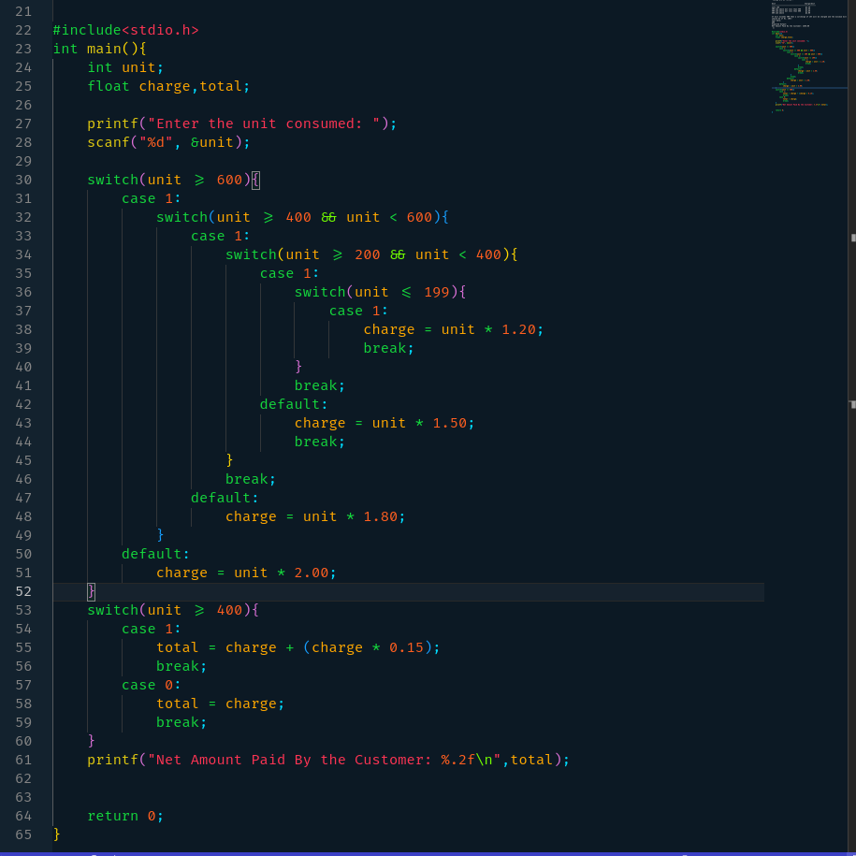

**Task-17:**

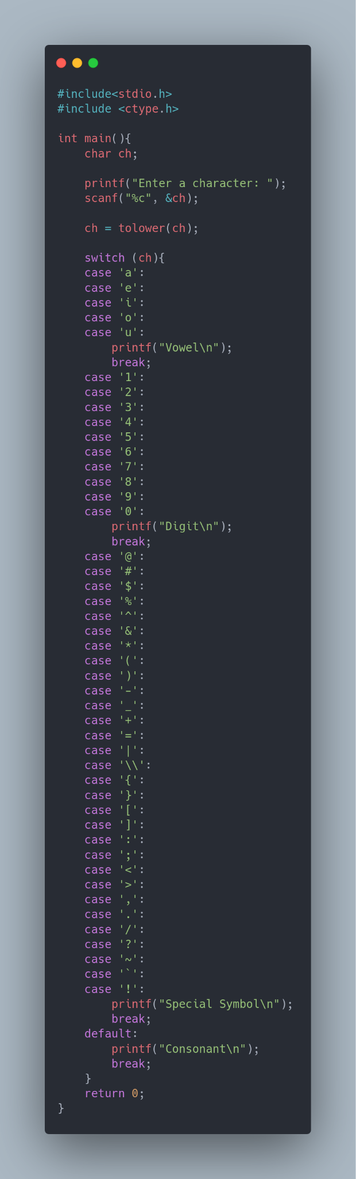

**5. TEST RESULT / OUTPUT [2]**

**Using If…Else Conditional Statement**

**Task-1:**

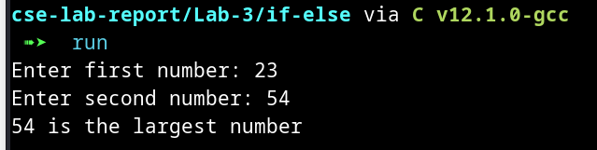

**Task-2:**

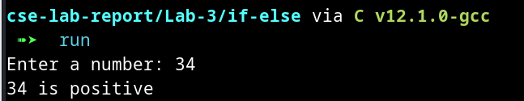

**Task-3:**

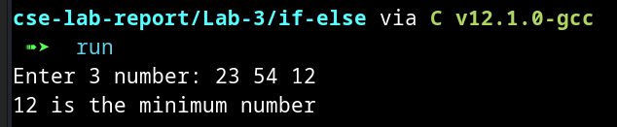

**Task-4:**

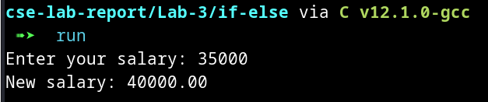

**Task-5:**

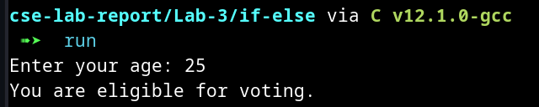

**Task-6:**

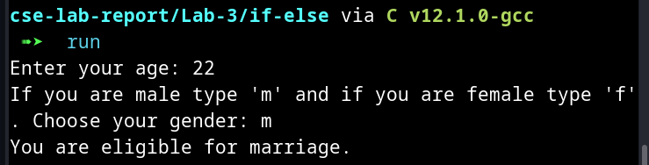

**Task-7:**

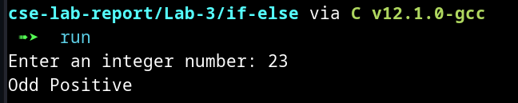

**Task-8:**

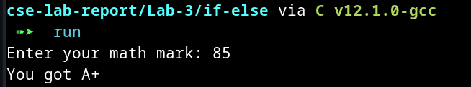

**Task-9:**

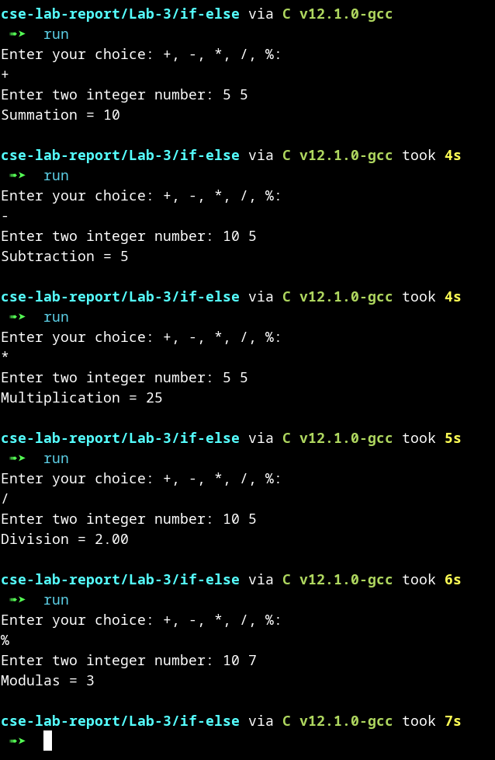

**Task10:**

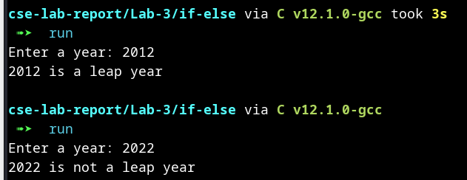

**Task-11:**

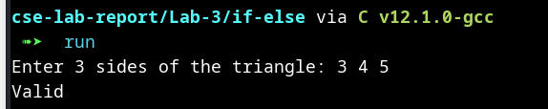

**Task-12:**

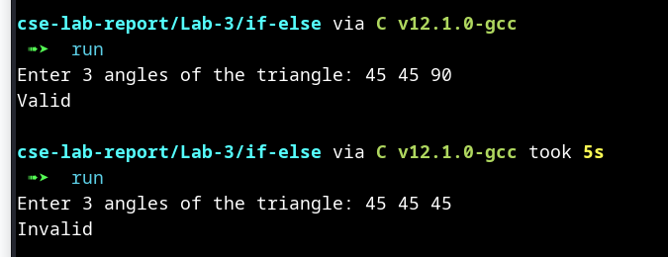

**Task-13:**

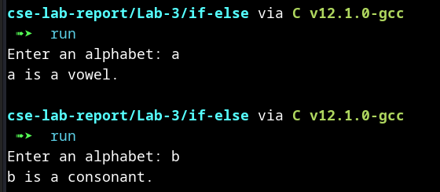

**Task-14:**

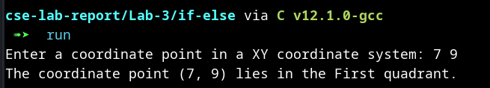

**Task-15:**

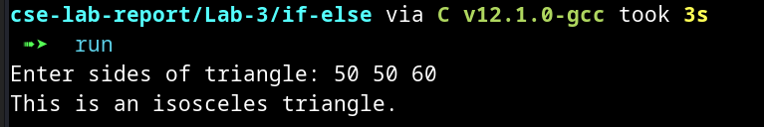

**Task-16:**

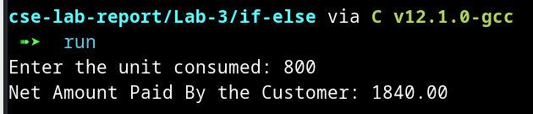

**Task-17:**

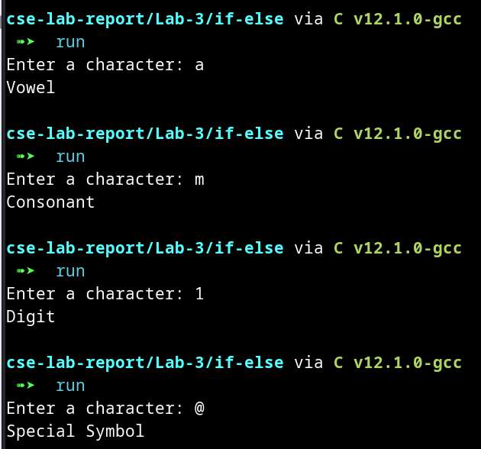

**Using Switch Statement**

**Task-1:**

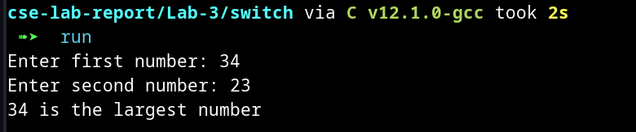

**Task-2:**

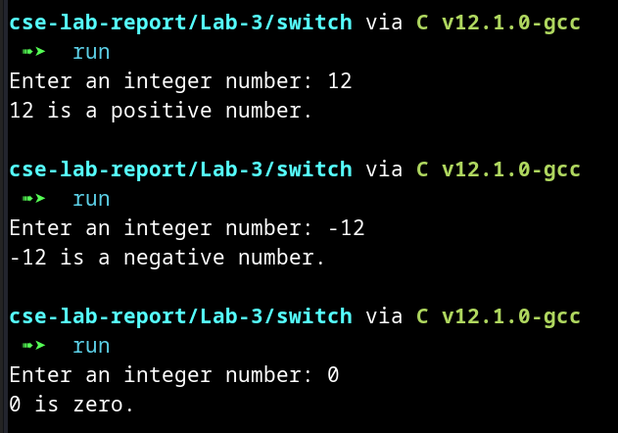

**Task-3:**

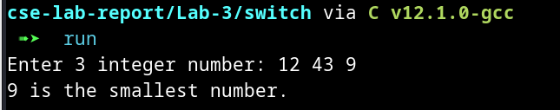

**Task-4:**

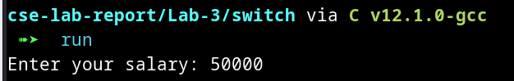

**Task-5:**

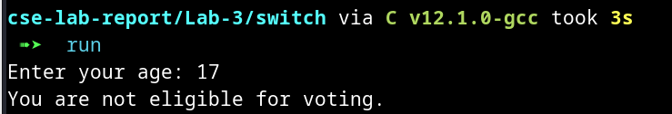

**Task-6:**

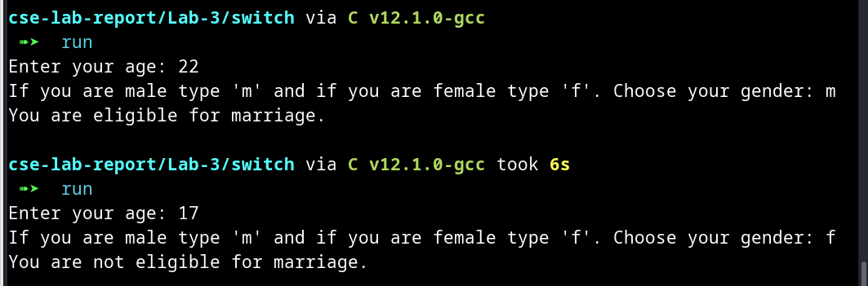

**Task-7:**

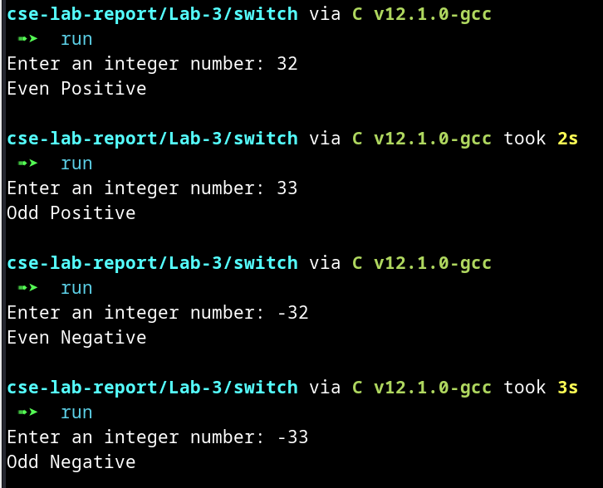

**Task-8:**

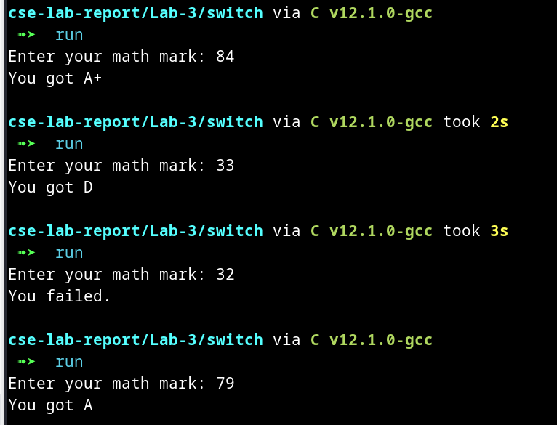

**Task-9:**

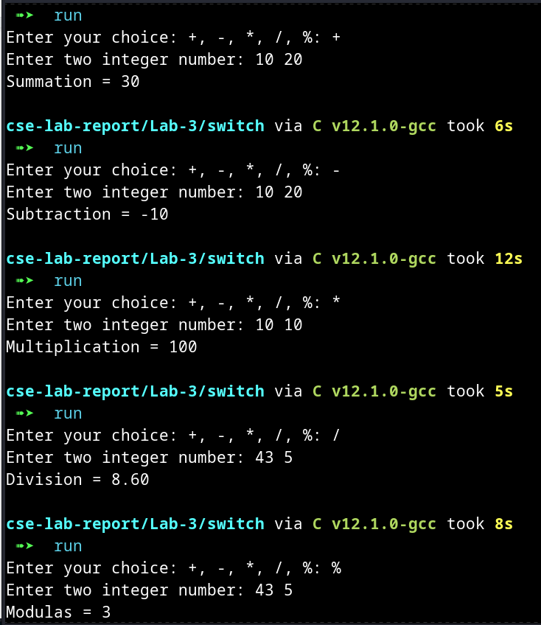

**Task-10:**

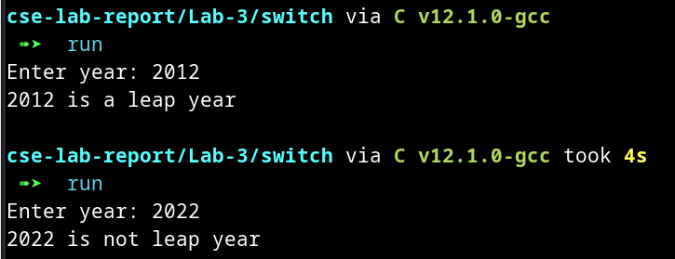

**Task-11:**

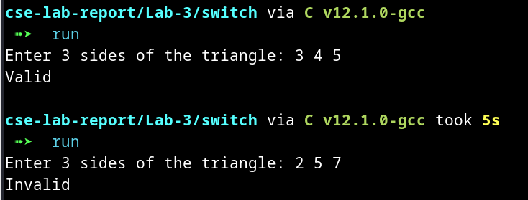

**Task-12:**

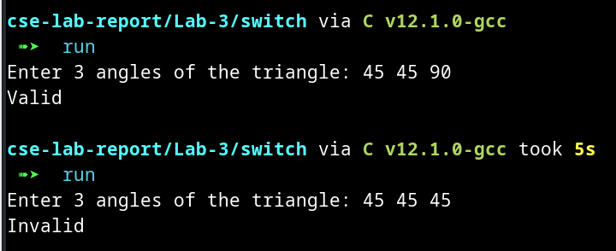

**Task-13:**

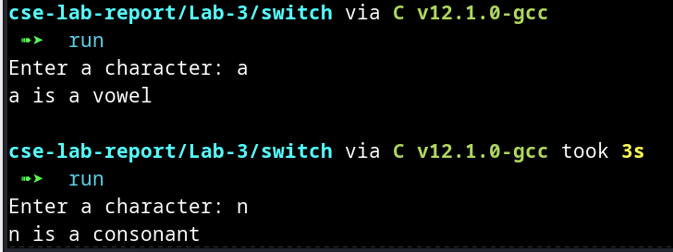

**Task-14:**

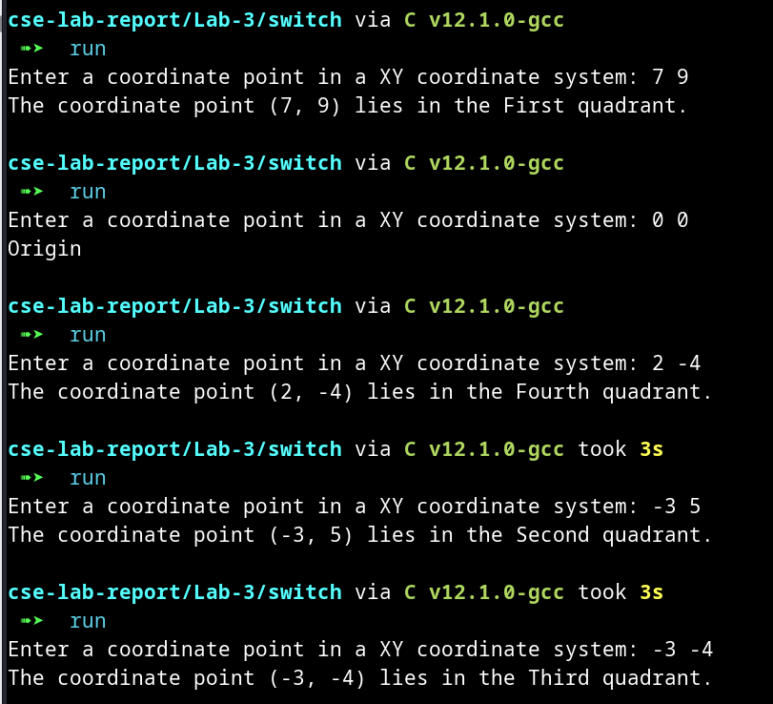

**Task-15:**

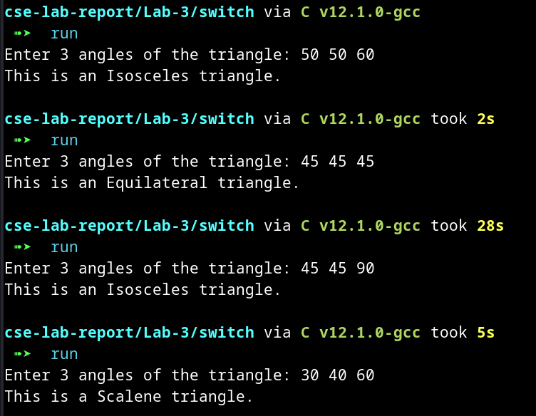

**Task-16:**

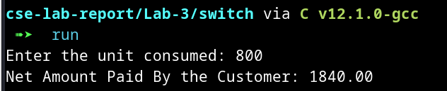

**Task-17:**

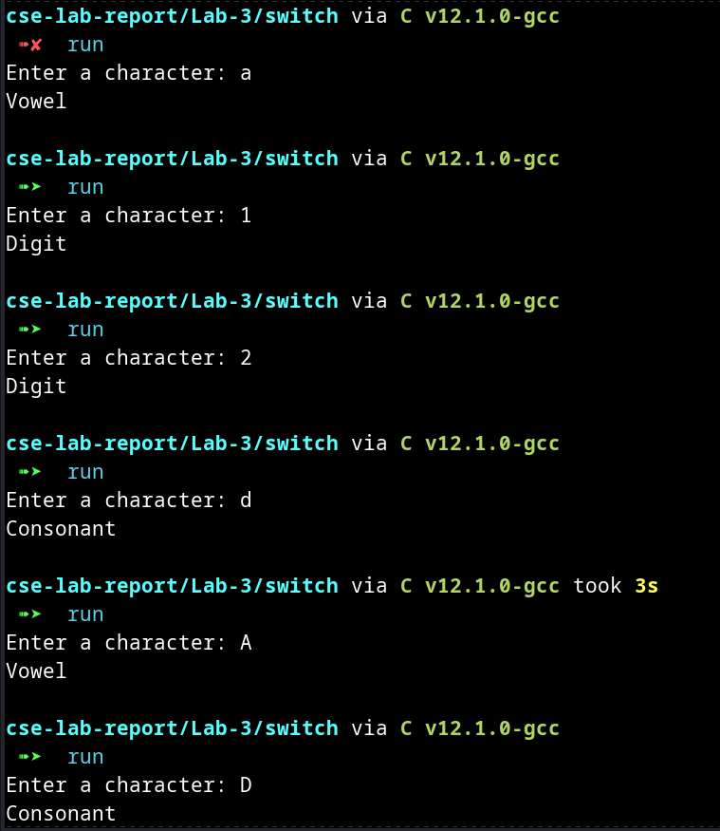

**6. ANALYSIS AND DISCUSSION [2]**

1. Everything is good—the output results in the previous section
2. Everything is good
3. I face trouble spots when solving the 16 and 17 number problems in this assignment
4. The switch part for the 16 and 17 I faced the most trouble. The logic is a little bit difficult for my program to implement
5. It’s perfect and it helps me to think deeply.
6. A lot of things. Especially the logic I implemented in the switch case statement. It’s a little bit difficult to solve. But I am ok with it.
7. I decide to solve a lot of problems on beecrowd using my current knowledge